Unit 6.6 : Thermal Expansion and Contraction
Topics : Factors influencing air pressure
Name:____________________
Class: _________________( )
Date: ____________________
Task 1: What are the water levels inside your straw?

- You are given a drinking straw and a cup of water.
- Stick the straw down into the water and observe the water level inside the straw.
- Hold your thumb over the top of the straw. Then, stick the straw down into water and observe the water level inside the straw.

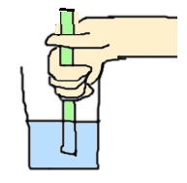  Figure 1a: Stick the straw down into water without holding thumb over its top | 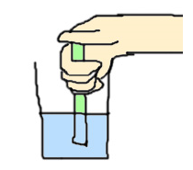  Figure 1b: Stick the straw down into water with holding thumb over its top

- As compared with the water level in the straw as in Figure 1b, what is the water level inside the straw by holding the top of straw? Explain briefly.
The water level is lower than that without holding the top of straw.
When we place a thumb over the top of the straw, the air inside the straw is not able to escape. When we stick the straw down into the water, the air remained in the straw exerted a pressure on the water from filling the straw. Thus, the water level is lower than that without holding the top of straw.

Task 2 : Gas expansion in water bath

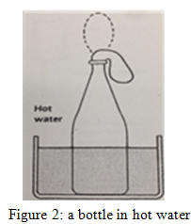
- You are given a small balloon, a bottle and two containers.
- Attach a small balloon over the top of the empty bottle.
- What will happen if we put the bottle into a container of hot water as Figure 2? Explain your answer.
The balloon expands and stands up.
When we attach a small balloon over the top of the empty bottle, the air is not able to escape. When we put the bottle into a container of hot water, the air inside the bottle expands due to the increase of temperature. Thus, the balloon expands and stands up.

- What will happen if we put the bottle into another container of cold water?
The balloon contracts and collapses.

- According to particle theory, the bottle is full of air particles. In the following two figures, use arrows to show the behaviours of air particles inside the bottles respectively.

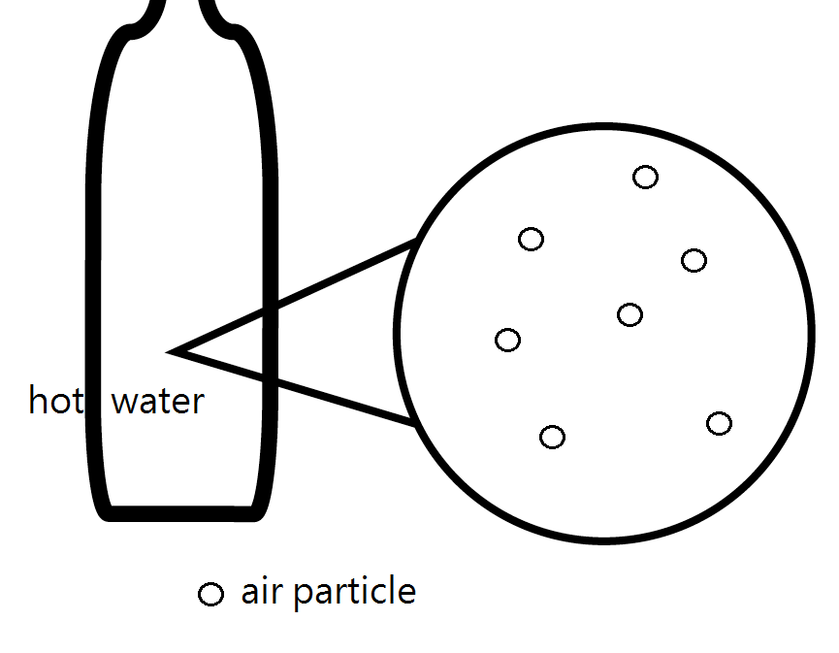  Figure 2a: The bottle into a container of hot water. | 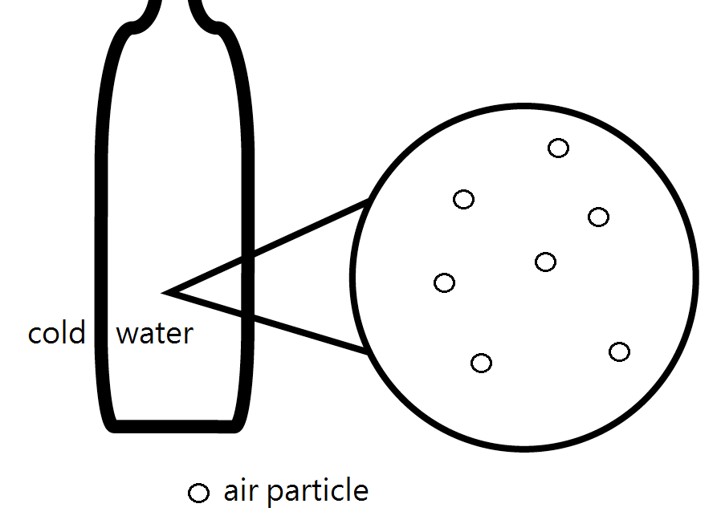  Figure 2b: The bottle into a container of cold water.

- Explain, in terms of particle theory, why the balloon expands when we put the bottle into the container of hot water.

There are air particles inside the bottle. When we put the bottle into the container of hot water, the air particles gain more energy. The particles move faster and collide on the wall of balloon stronger and more frequently. Thus the air pressure inside the bottle increases and the balloon expands.

Task 3: Using particle theory to explain everyday life examples

Scenario One: Restoring ‘pressed’ table tennis

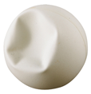
- You are given a “pressed” table tennis ball with a concave shape shown as below. Suggest a method to restore its shape.

Using the space below, describe your suggestion.
Put the ‘pressed’ table tennis into hot water. The ‘pressed’ table tennis will restore its shape.

- Using particle theory, explain why your suggestion could restore the shape of the ‘pressed’ table tennis.
When we put the pressured table tennis into hot water, the air particles inside the table tennis gained more energy. The particles move faster and collide on the wall of table tennis more frequently. Thus, the air pressure inside the ‘pressed’ table tennis exerted pressure on the wall and restore its shape.

Scenario Two: Getting an egg into a bottle
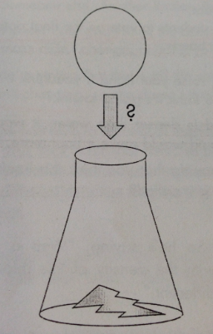
- You are given a boiled egg that is placed on the top of the bottle. Suggest a method to let the egg go into the bottle without breaking the egg.

- Using the space below, describe your suggestion.

- Now your teacher shows you a video clip on getting an egg into a bottle. Using particle theory, explain why the egg could get into the flask with the hot water inside the bottle.
(source: https://www.youtube.com/watch?v=b8_UVwvMfNA)

When we pour hot water into the bottle, the air particles inside the bottle gained more energy. Some air particles escape from the bottle. When the bottle cools down, the air pressure is rather low inside the bottle. Thus, the air pressure outside the flask is greater than that inside. Hence, the air pressure outside the flask will push the egg into the bottle.

According to the above two scenarios, what are the two factors influencing the air pressure?
- The energy gained by the air particles
- The number of air particles

Task4: Use particle theory to explain your prediction

A balloon is placed in an air-tight box connected to a vacuum pump shown as below.

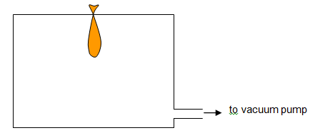

- If we turn on the pump, what will happen to the balloon? Draw the shape of balloon in Figure 4b to show your answer.

The balloon will expand

- In the following two figures, draw the air particles inside the air-tight box to show the differences before and after turning on the vacuum pump respectively.

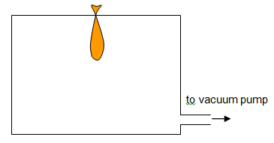Fig 4a: Before turning on the vacuum pump | 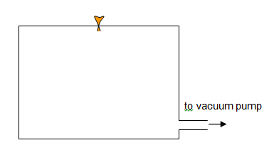Fig 4b: After turning on the vacuum pump

- Using particle theory to explain your answer in (a).

When we turn on the vacuum pump, some air particles are pumped out from the air-tight box. Fewer particles hit the wall of the container and the air pressure inside the air-tight box decreases. The air pressure outside is greater than the pressure inside. Thus the pressure difference forces the balloon to expand.

